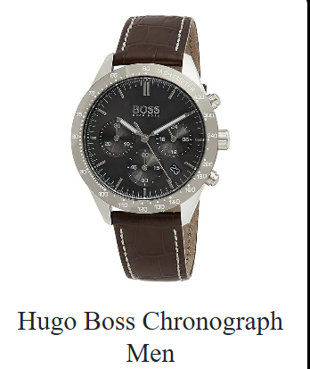

### Product Name:

**Hugo Boss Chronograph Men’s Watch**

### Description:

A stylish and elegant men's chronograph watch by Hugo Boss. It features a black dial, stainless steel case, and a brown leather strap with a crocodile pattern. Ideal for formal or business wear.

### Specifications:

* **Display:** Analog
* **Movement:** Quartz
* **Functions:** Chronograph, Date, Hour/Minute/Second
* **Strap:** Brown leather
* **Dial:** Black
* **Water Resistance:** Basic (3–5 ATM)

**Price**: **₹18,000 INR**